***Chemistry***

**11: Solutions and Colloids**

**11.2: Electrolytes**

9. Explain why the ions Na+ and Cl− are strongly solvated in water but not in hexane, a solvent composed of nonpolar molecules.

Solution

Crystals of NaCl dissolve in water, a polar liquid with a very large dipole moment, and the individual ions become strongly solvated. Hexane is a nonpolar liquid with a dipole moment of zero and, therefore, does not significantly interact with the ions of the NaCl crystals.

11. Consider the solutions presented:

(a) Which of the following sketches best represents the ions in a solution of Fe(NO3)3(*aq*)?

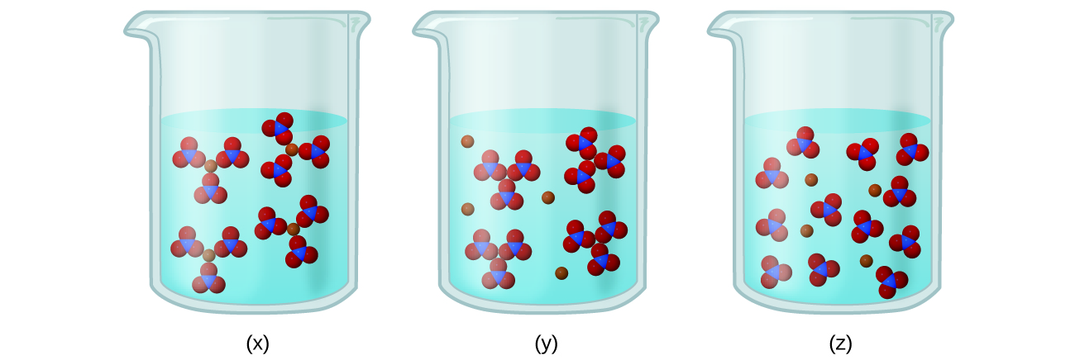

(b) Write a balanced chemical equation showing the products of the dissolution of Fe(NO3)3.

Solution

(a) Fe(NO3)3 is a strong electrolyte, thus it should completely dissociate into Fe3+ and  ions. Therefore, (z) best represents the solution. (b)



13. What is the expected electrical conductivity of the following solutions?

(a) NaOH(*aq*)

(b) HCl(*aq*)

(c) C6H12O6(*aq*) (glucose)

(d) NH3(*aq*)

Solution

(a) high conductivity (solute is an ionic compound that will dissociate when dissolved); (b) high conductivity (solute is a strong acid and will ionize completely when dissolved); (c) nonconductive (solute is a covalent compound, neither acid nor base, unreactive towards water); (d) low conductivity (solute is a weak base and will partially ionize when dissolved)

15. Indicate the most important type of intermolecular attraction responsible for solvation in each of the following solutions:

(a) the solutions in Figure 11.8

(b) methanol, CH3OH, dissolved in ethanol, C2H5OH

(c) methane, CH4, dissolved in benzene, C6H6

(d) the polar halocarbon CF2Cl2 dissolved in the polar halocarbon CF2ClCFCl2

(e) O2(*l*) in N2(*l*)

Solution

(a) ion-dipole; (b) hydrogen bonds; (c) dispersion forces; (d) dipole-dipole attractions; (e) dispersion forces

This resource file is copyright 2015, Rice University. All Rights Reserved.